The “TestFiles\TestSet\“TestSet.txt” file contains 10 logged Java methods I selected as the test set. The “TestFiles\TestSet\OutPut.txt” is the output file created by our tool after anti-unifying a set of AUASTs extracted from logged Java methods in the test set using a hierarchical clustering algorithm. The Figure 1 represents the hierarchy of these clusters.

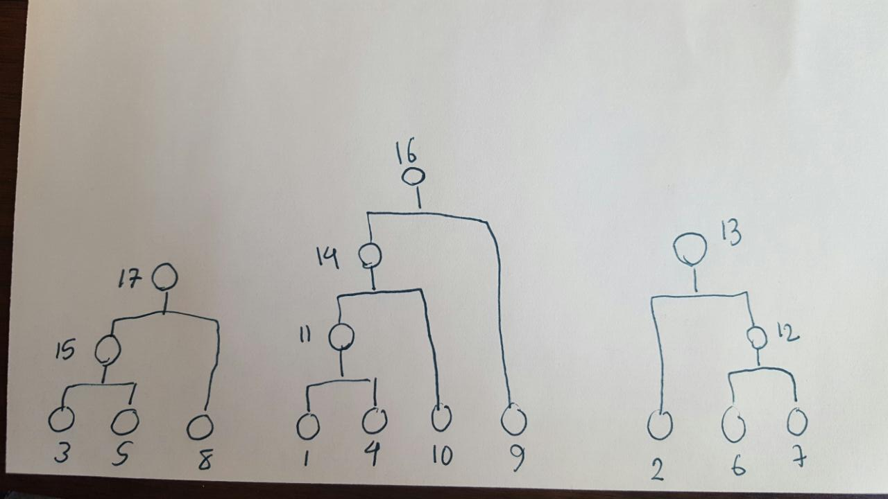

Figure 1. The hierarchy of clusters after applying the clustering algorithm on “TestSet.text”.

Anti-unifiers are discarded when anti-unification of AUASTs does not allow the anti-unification of logging calls and while the structures containing them are not corresponded. Thus, as you can see we will come up with three root clusters and these clusters cannot be merged with each other.